**VISVESVARAYA TECHNOLOGICAL UNIVERSITY**

**“Jnana Sangama”, Belgaum -590014, Karnataka.**



**PROJECT WORK-1 REPORT**

**on**

**E-COMMERCE WEBSITE**

**(FASHION FIESTA)**

***Submitted by***

**IMADH AJAZ BANDAY (1BM20CS059)**

**JAYAM MOUNEASH (1BM20CS063)**

**KANKSHIT P BHOJANE (1BM20CS068)**

**JYOTIRADITYA SINGH BAGHEL(1BM20CS064)**

***Under the Guidance of***

|  |  |
| --- | --- |
| **Dr. MANJUNATH D R**  **ASSISTANT PROFESSOR, BMSCE** |  |

***in partial fulfillment for the award of the degree of***

**BACHELOR OF ENGINEERING**

***in***

**COMPUTER SCIENCE AND ENGINEERING**



**B.M.S. COLLEGE OF ENGINEERING**

**(Autonomous Institution under VTU)**

**BENGALURU-560019**

**Oct 2021-Feb 2022**

**B. M. S. College of Engineering,**

**Bull Temple Road, Bangalore 560019**

(Affiliated To Visvesvaraya Technological University, Belgaum)

**Department of Computer Science and Engineering**



**CERTIFICATE**

This is to certify that the project work entitled “**E-COMMERCE WEBSITE (Fashion Fiesta)**” carried out by IMADH AJAZ BANDAY(1BM20CS059), JAYAM MOUNEASH (1BM20CS063), KANKSHIT P BHOJANE(1BM20CS068), JYOTIRADITYA SINGH BAGHEL(1BM20CS064) who are bonafide students of **B.M.S. College of Engineering.** It is in partial fulfillment for the award of **Bachelor of Engineering in Computer Science and Engineering** of the Visveswaraiah Technological University, Belgaum during the year 2021-2022. The project report has been approved as it satisfies the academic requirements in respect of **Project Work-1 (19CS3PWPW1)** work prescribed for the said degree.

Signature of the Guide                 Signature of the HOD

**Dr. Manjunath D R** **Dr. Jyothi S Nayak**

Assistant professor Prof & Head of Dept of CSE

BMSCE, Bengaluru BMSCE, Bengaluru

External Viva

Name of the Examiners                                                                                       Signature with date

1._____________________________ ________________________

2. _____________________________ _________________________

**B.M.S. COLLEGE OF ENGINEERING**

**DEPARTMENT OF COMPUTER SCIENCE AND ENGINEERING**



***DECLARATION***

We, IMADH AJAZ BANDAY(1BM20CS059), JAYAM MOUNEASH (1BM20CS063), KANKSHIT P BHOJANE(1BM20CS068), JYOTIRADITYA SINGH BAGHEL(1BM20CS064) students of 3rd Semester, B.E, Department of Computer Science and Engineering, B.M.S. College of Engineering, Bangalore, hereby declare that, this Project Work-1 entitled "**E-COMMERCE WEBSITE (Fashion Fiesta)**" has been carried out by us under the guidance of **Dr. MANJUNATH D R,** Assistant Professor, Department of CSE, BMS College of Engineering, Bangalore during the academic semester Oct 2021 -Feb 2022.

We also declare that to the best of our knowledge and belief, the development reported here is not from part of any other report by any other students.

Signature

IMADH AJAZ BANDAY (1BM20CS079)

JAYAM MOUNEASH (1BM20CS063)

KANKSHIT P BHOJANE(1BM20CS068)

JYOTIRADITYA SINGH BAGHEL(1BM20CS064)

**TABLE OF CONTENTS**

|  |  |  |
| --- | --- | --- |
| **CHAPTER NO.** | **TITLE** | **PAGE NO.** |
| 1 | **Introduction** |  |
| 1.1 | Overview | 5 |
| 1.2 | Motivation | 5 |
| 2 | **Software Requirement Specification** |  |
| 2.1 | Hardware Requirements | 6 |
| 2.2 | Software Requirements | 6 |
| 3 | **User Interface Design** |  |
| 3.1 | Home Page | 7 |
| 3.2 | Products Page | 8-9 |
| 3.3 | About Us Page | 10 |
| 3.4 | Contact Us | 11 |
| 3.5 | SignIn Page | 12 |
| 3.6 | Cart Page | 13-14 |

**Chapter 1**

**INTRODUCTION**

**1.1 Overview**

Website for “Online Shopping(Fashion Fiesta)”.

Online shopping system is an e-commerce platform in which one can order various shopping items like clothes and other accessories from some local store through the use of internet, just by sitting at any place.

Our website allows people to order the items with multiple delivery options.

.

**1.2 Motivation**

Our major advantages can be summarized as follows:

(1) Our store provides all the fashion items from various famous brands all at a single place.

(2) Allows customers with exclusive offers from time to time.

(3)Efficient account creation for users for timely updates about new offers.

(4)No reach limitations and different sections available for various men & women products.

(5)Easy checkout and multiple delivery in cart items.

**Chapter 2**

**SOFTWARE REQUIREMENTS**

**2.1 Hardware Requirements:**

* A PC with the following or greater specifications:
  + Intel Core i7 (6th gen or higher)
  + 8 GB RAM
  + 500 GB Hard Drive
* A stable internet connection (2Mbps or higher).

**2.2 Software Requirements:**

* Operating system : Windows 10, MacOS, Linux, Ubuntu
* Technologies : HTML, CSS, Javascript
* IDE : VS Code

**Chapter 3**

**USER INTERFACE DESIGN**

**1. Home Page Screen**

**This page allows users to:**

(1) Search for various trending and latest products.

(2) Get information about some of the exclusive products available on Fashion Fiesta.

(3) Leads us to About Page

(4) Leads us to Contact Page

(5) Leads us to Account sign or SignIn Page

(4) See items in Cart.

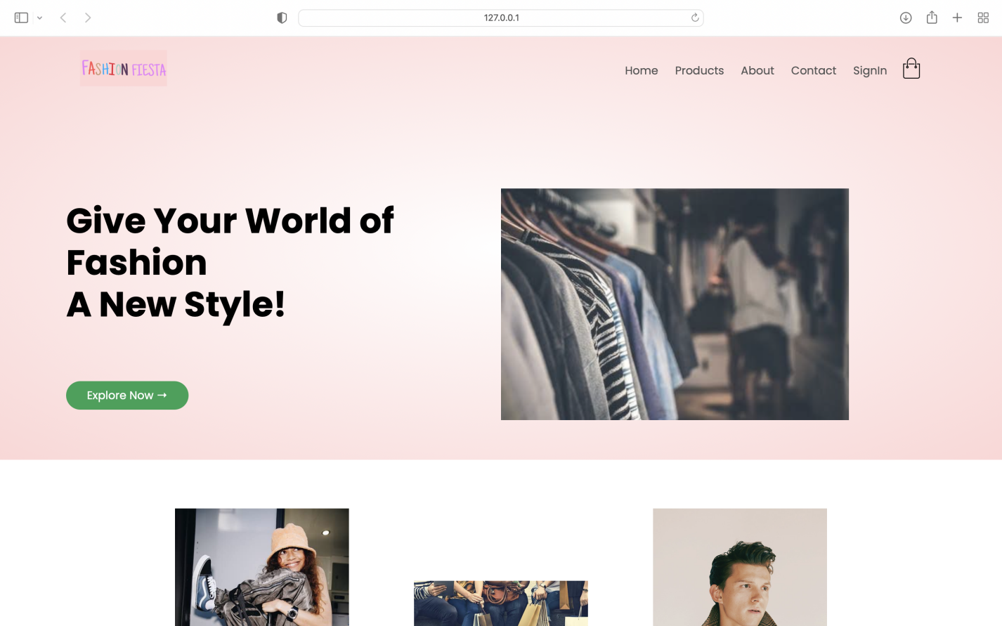

Fig.1 Home Page

**2.Products page**

The products page leads to all the product items with different sections, like men and women sections featuring different product sections and sorting options. Each product has an item rating associated with it and also the price details.

The **Men** and **Women** sections of this page also contain different varieties of products for men and women separately.

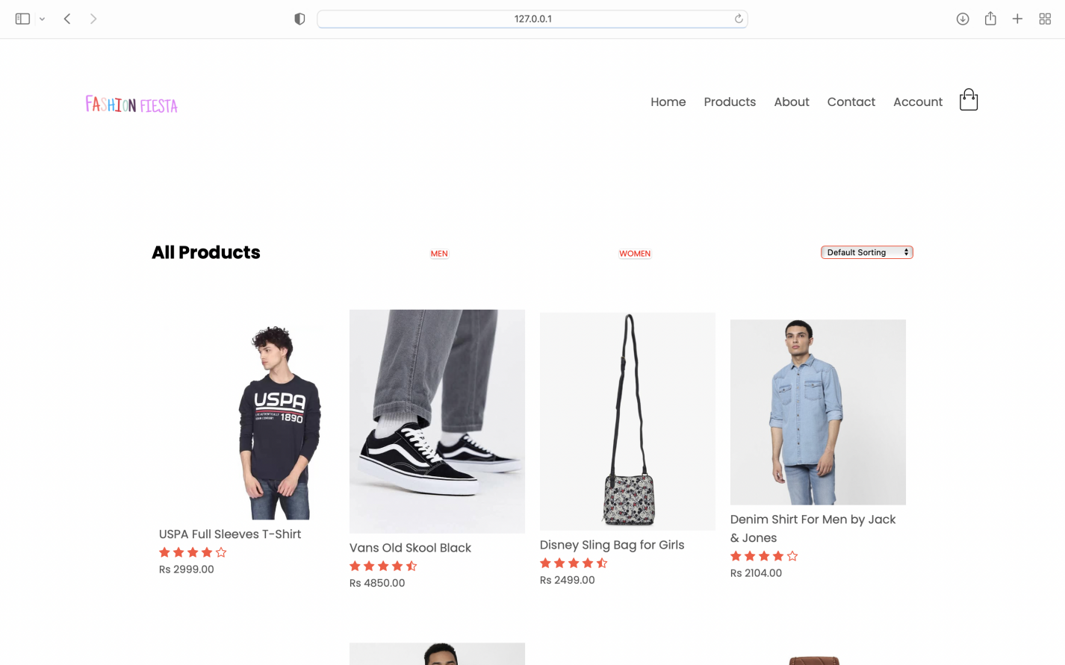

Fig.2 Products Page

On clicking on any of the products, it leads us to the product details page. One can add as many items as they wish to, to the cart from this section and proceed to checkout.

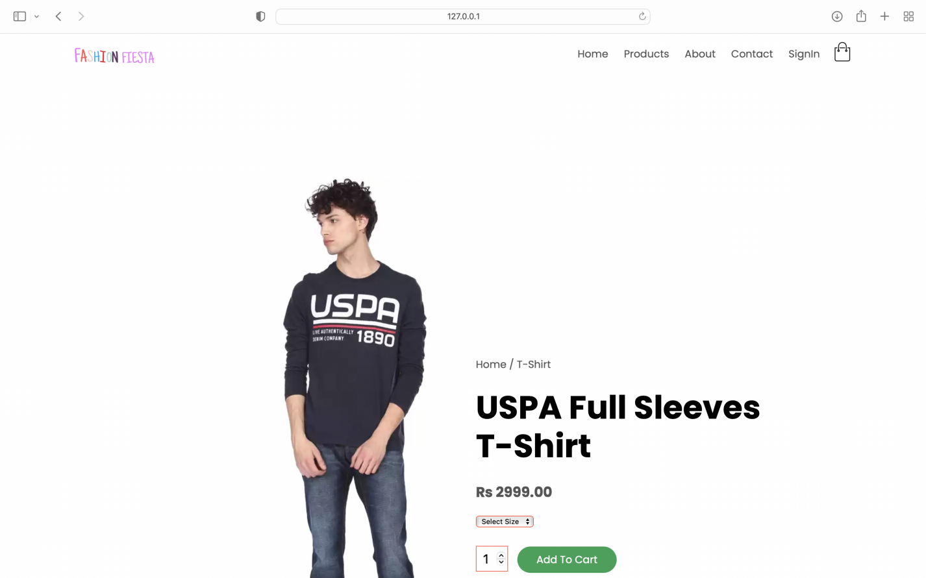

Fig.2.1 Products Details Page

**3.About Us page:**

This web page tells you about the creators and developers of this Fashion Fiesta store.

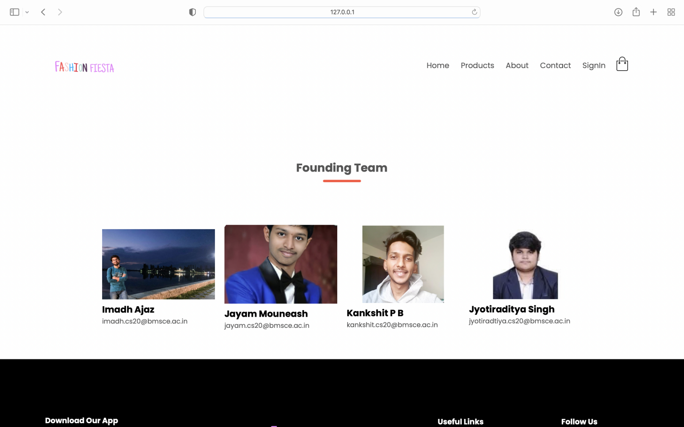

Fig.3 About Us Page

**4. Contacts page**

Fashion Fiesta has got you covered with its helpline 24x7. Our team of executives are always there to help in case of any need to the valuable customers of our store. Users can simply drop a message or call on any of the helpline numbers whenever they feel the need to do so.

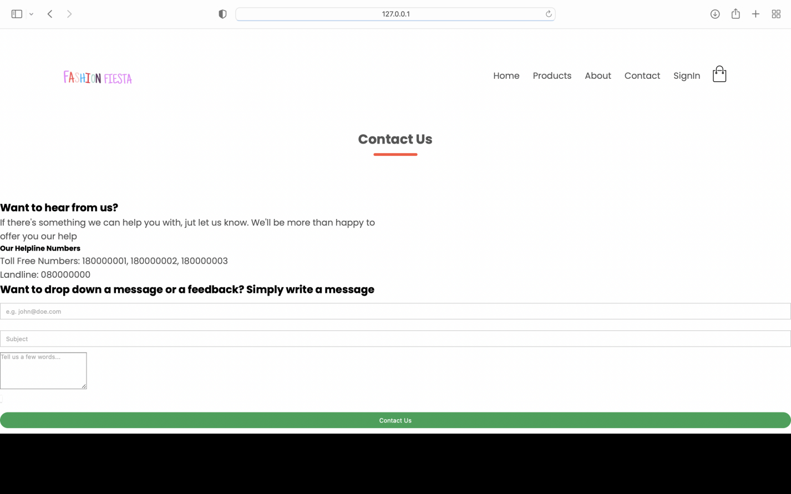

Fig.4 Contact Us Page

**5. SignIn page**

(1) This page enables user to create a new account with fashion fiesta.

(2) It also allows pre-registered users to simply login to fashion fiesta and have updates about all the products from time to time.

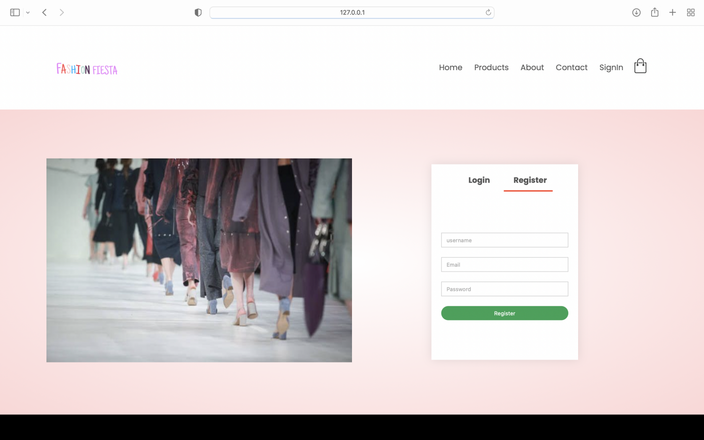

Fig.5 SignIn Page

**6. Cart Page**

(1) Displays the product detail which we have selected.

(2) Allow’s the item to be added to cart.

(3) Allows users to go with a multiple delivery option.

(4) The multiple delivery option is available for both inter and intra city delivery options.

(5) As of now, users can select a maximum of three multi delivery options.

**THOUGHT BEHIND MULTI-DELIVERY OPTION?**

Unlike many other E-commerce stores available in the market, fashion fiesta provides you with a multi delivery option for items available in a single cart. This is turn helps users to split bill with other common buyers or friends while they get amazing discounts on buying items from single cart at a time.

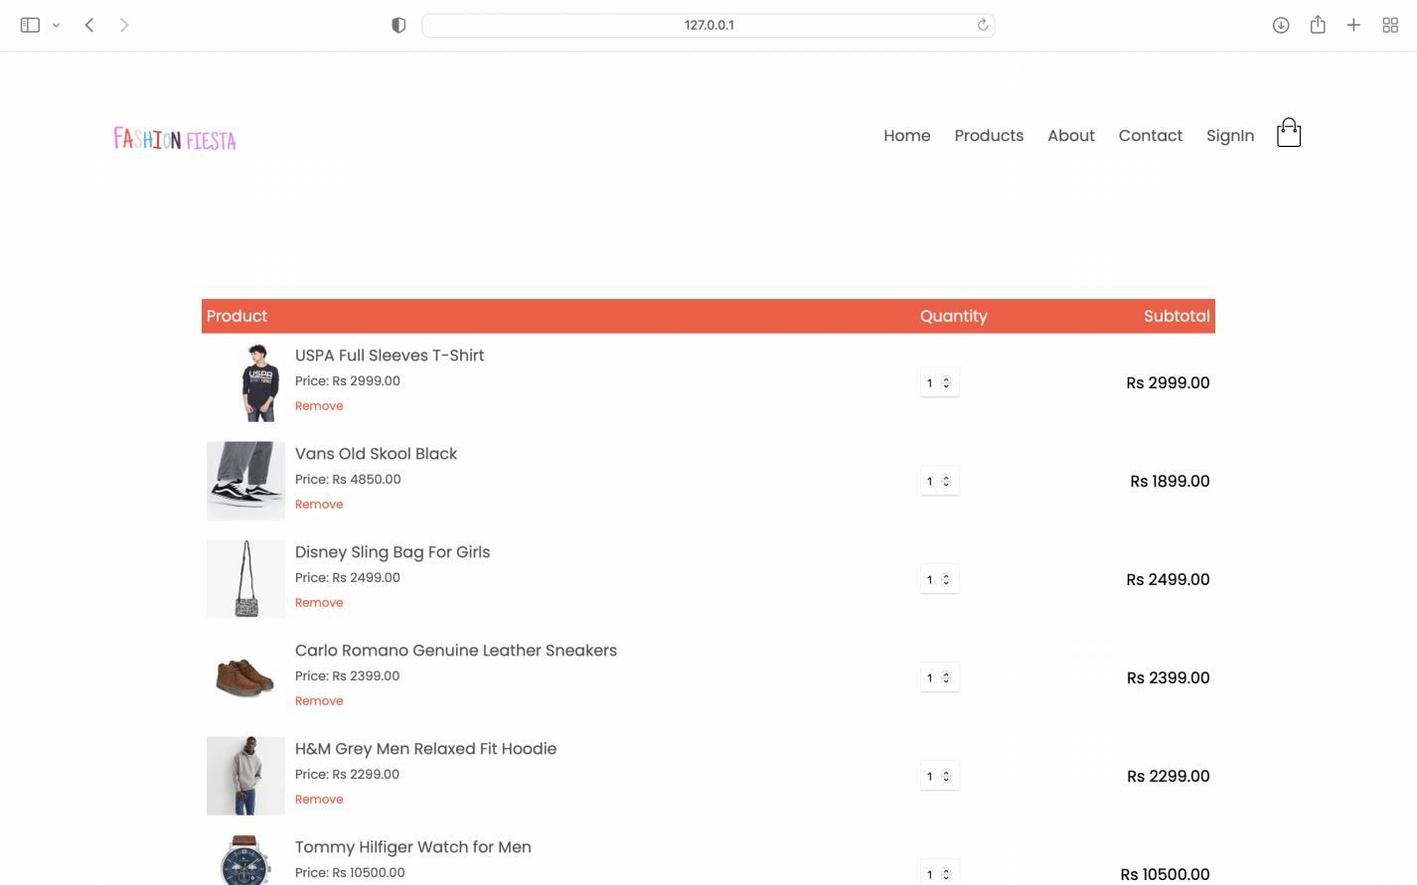

Fig.7.1 Cart Page (After adding items)

After adding items in cart, and proceeding for multi-delivery option, it displays this.

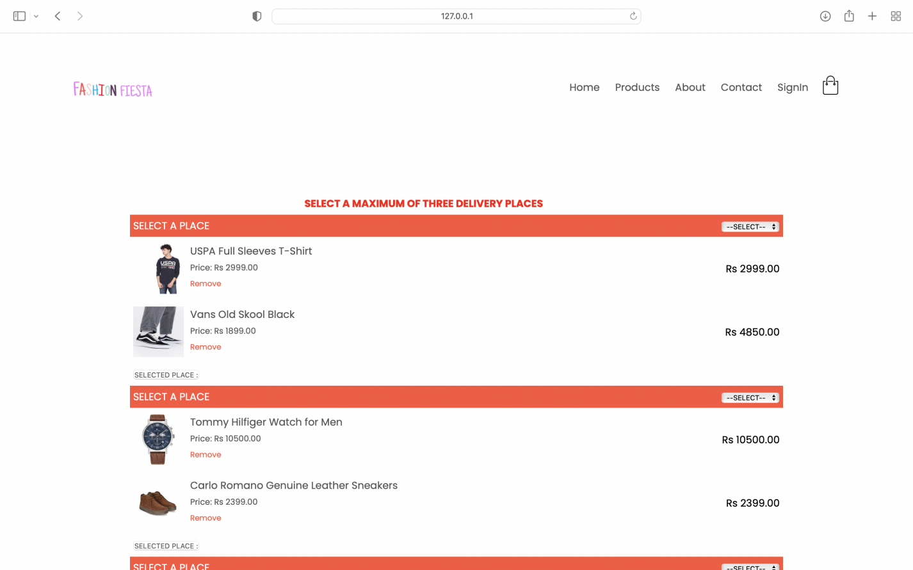

Fig.7.2 Cart Page (Multi-Delivery Option)